Kingham
Annual Parish Meeting

to be held on Wednesday 20 March 2024

at 7.00 pm

in the Village Hall

Agenda

1. Apologies – to be received.

2. Minutes – minutes of the previous meeting to be approved and signed

3. Parish Council Chairman’s report

4. County Councillor’s report

5. District Councillors’ reports

6. Thames Valley Police report

Refreshments

6. Open Meeting

7. AOB

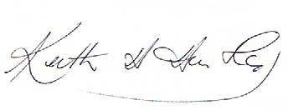Chairman, Kingham Parish Council

