Kingham
Annual Parish Meeting

to be held on Wednesday 15 March 2023

at 7.30 pm

in the Village Hall

Agenda

1. Apologies – to be received.

2. Minutes – minutes of the previous meeting to be approved and signed

3. Parish Council Chairman’s report

4. County Councillor’s report

5. District Councillors’ reports

Refreshments

6. Open Meeting

7. AOB

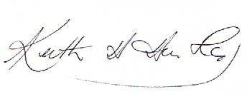Chairman, Kingham Parish Council

